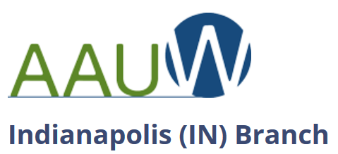

AAUW is a community that breaks through educational and economic barriers so that all women have a fair chance. Your membership makes AAUW’s powerful voice even stronger on critical issues affecting women and girls.
$91 annual dues include membership in local, state, and national association. (Make check payable to AAUW Indianapolis: send to Finance Officer, AAUW Indianapolis, 9291 Golden Leaf Way, Indianapolis, IN 46260.)
To join online, go to www.aauw.org and choose “Branch Membership.”
Personal Information
Name: First _____________________________ M. _______ Last _______________________________________________
Address __________________________________________________________________________________________________
City/state/zip ___________________________________________________________________________________________
Phone (h) (____) _____-_________ Phone (w) (____) _____-_________ Phone (m) (____) _____-_________
Email _____________________________________________________________________________________________________
College/University ________________________________________________________________ State_____________
Highest degree earned ____________________________________________________________ Year _____________
Major ______________________________________________________ Date of birth ____________________________
Eligibility
I am a graduate holding an associate or equivalent (RN), baccalaureate, or higher degree from
a regionally accredited institution, as stated above.
_____________________________________________________________________________ _________________________
Signature Date

AAUW Indianapolis Branch contacts:
VP Membership Open
VP Program Jan Doyle janpfd@gmail.com
Communications Officer Sherry Watkins sherryindy3@aol.com
Finance Officer Marti Daily m-daily@comcast.net
Co-Presidents Barb Wellnitz barb@bwellnitz.com
Peggy Wild wildpeggy1@gmail.com

AAUW Web sites:
(National) www.aauw.org
(Indiana) https://aauw-in.aauw.net/
(Indianapolis) http://indianapolis-in.aauw.net

